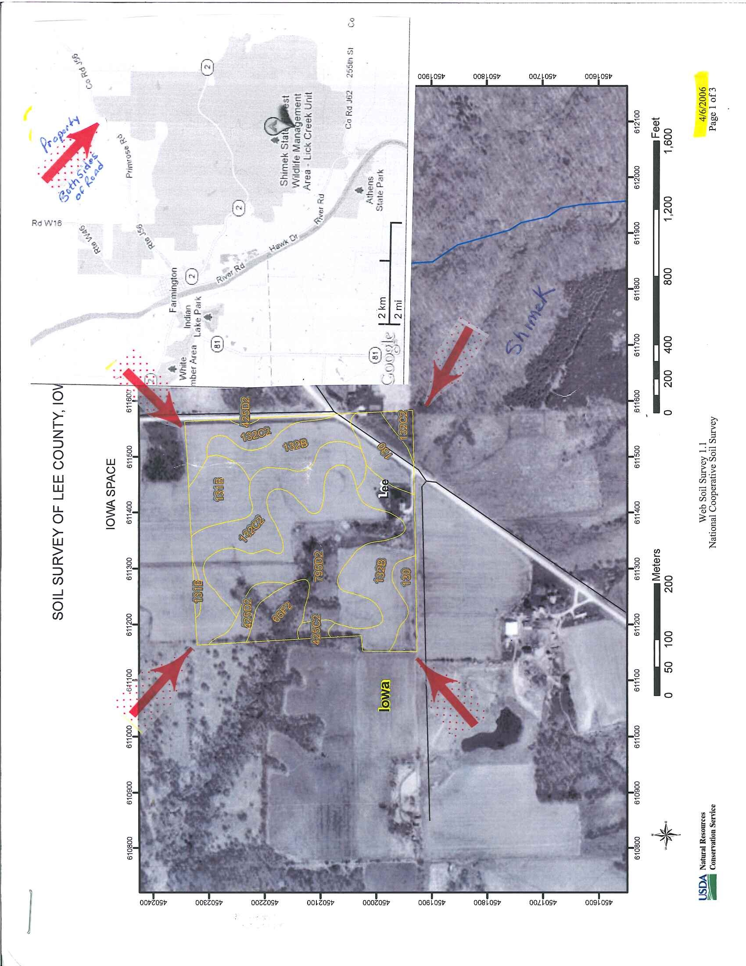
38.25 Acreage for sale
Located 4 mi west of Farmington Co Rd J56 (a.k.a. Primrose Road) Corner of 120th Ave/Primrose Road marks SW corner of acreage and is ½ mi east of Sheimek Lick Creek Unit Entrance.

27 acres Conservation Reserve Program + cost share to 9/30/2020
5.1 acres in Wildlife Habitat Buffer Program +cost share
1.3 acres in New Grassed Waterway Program +cost share
USDA annual payment $2,700 Annual tax $556
Rural Water access, no structures, DNR pond site approval
Parcel price $135,000
Contact Jane Benjamin (541) 343-3826 or benjaminj@lanecc.edu

