Reece Egyptian Feta Cheese & Green Fava Beans

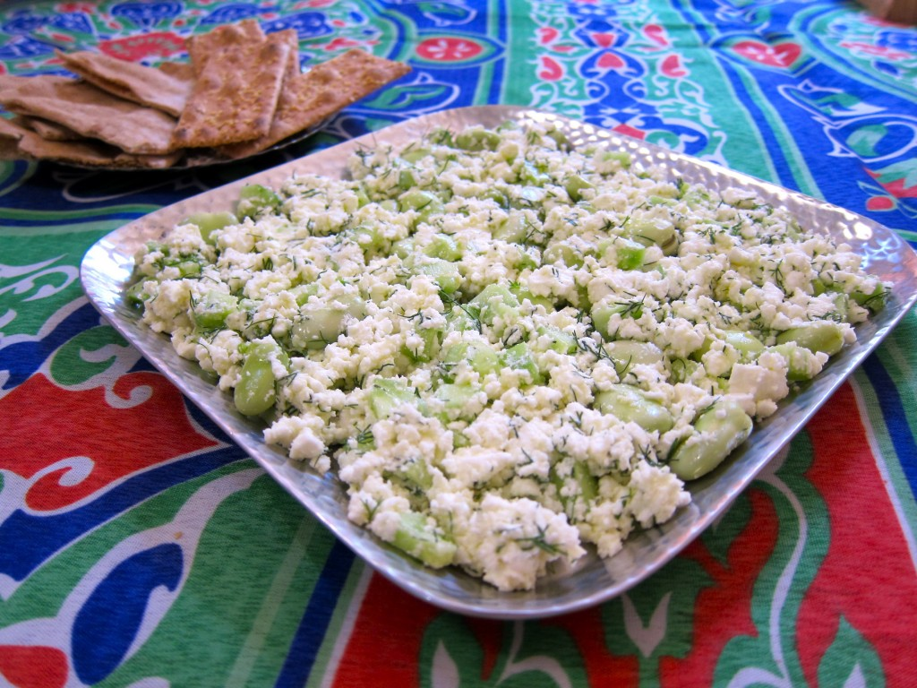

Serving Ideas: Serve at breakfast with pita bread or crackers. Add to a vegetarian menu.

Serving Size: 4-6 people
Ingredients:
20 pods of fava beans
10 ounces of feta cheese
1Tbs fresh dill, finely chopped
3Tsb extra virgin olive oil
1 small cucumber seeded & chopped
1 clove of garlic, crushed and finely chopped

Origin of Ingredients:

Fava Beans: date back 3300- 1200 BC. They are believed to have originated from the Ancient New East, which is present day Middle East. The fava beans spread like wildfire and can be found in Europe, Ancient Egypt, China, India, Africa, and Latin America. The fava bean is the original bean of the 12th nigh cake and symbolizes good luck. Fava Beans signify the ancient Pharaohs of Egypt and are eaten with every meal. It is the national dish in Egypt.

Feta Cheese: is one of the most famous Greek cheeses. It originated in Greece. Feta is mainly found and produced in Macedonia, Thrace, Thessaly, Central Mainland Greece, the Peloponnese, and Lesvos. The word ‘Feta’ means slice and was first used in the 17th century by the Greeks. Feta is thought to have dated back to Homer’s time. Today feta is the most consumed cheese in Greece. In Egypt they found that their cattle could produce farm-style cheeses and their version of feta is symbolic to the builders of the pyramids and back during the times of the Pharaohs.

Dill: is also referred to as dill weed. Dill comes from the Old Norse word ‘dilla’ meaning calm or soothing. Dill originated in southern Russia, the Mediterranean, and West Africa. Before dill was used in food it was used as a medicine. Romans believed that dill brought good fortune. The Romans also used dill leaves in wreaths to recognize athletes and heroes. In the ‘old wives tales’ dill was hung over doors or entrances to symbolize love and protection. The ancient Egyptians used dill as a medicine and also in aphrodisiacs and to ward off witches.

Olive Oil: is considered to be the greatest natural asset of the ancient world. Olive oil dates back to 2400 BC and originated in Syria in an ancient city- sate of Elba. Olive branches are said to be a symbol of peace. The olive tree, according to legend, was a gift from the goddess Athena. To the Greeks, if athletes rubbed the oil over their bodies before participating it would help protect their skin from abrasions and the elements. Egyptians used olive oil in religious ceremonies and as external ointment.

Cucumbers: date back 4000 years ago and were first spread beyond Indian borders, Ancient Greece, Rome, Europe, New World, and China. Cucumbers eventually became the most cultivated vegetable in the world. They originated in Ancient India were they grew in the wild. In Hebrew the word for cucumber is qishshu and comes from a root word meaning to be hard. In the bible, God hardened the heart of the Pharaoh so that the Egyptians and Israelites could see that God was the one who saved them from slavery.

Garlic: originated from central Asia and is now cultivated in many countries and grows wild in Italy and southern Europe. During the times of the Pharaohs, garlic was given to the builders and slaves who were building the pyramids to increase their stamina and strength and to protect them from disease. A Greek historian by the name of Herodotus wrote that on one of the Egyptian pyramids there are inscriptions in Egyptian characters informing the amount of garlic, onions, and radishes consumed by the builders of the pyramid of King Khufu.
Cited Page:

http://www.reluctantgourmet.com/fava-beans/
http://www.epicurious.com/recipes/food/views/ful-medames-352993
http://www.cheese.com/feta/
http://www.greek-feta-cheese.com/history.html
http://www.indepthinfo.com/dill/history.htm
http://www.explorecrete.com/nature/olive-oil-history.html
http://www.oliveoilsyria.com/history.htm
http://kaufmann-mercantile.com/the-history-of-olive-oil/
http://www.vegetablefacts.net/vegetable-history/history-of-cucumbers/
http://godasagardener.com/tag/symbolism-hard/
http://www.herballegacy.com/Porritt_History.html

