How to View a Scenario

Follow these simple steps to view the Scenarios in great detail.
Once you have opened up the website: http://lanecountycommissioner.moonshadowmobile.com/
you will see a screen that looks like this:
Please Note: You must have Internet Explorer version 8 or higher, Google Chrome, or Safari to view this.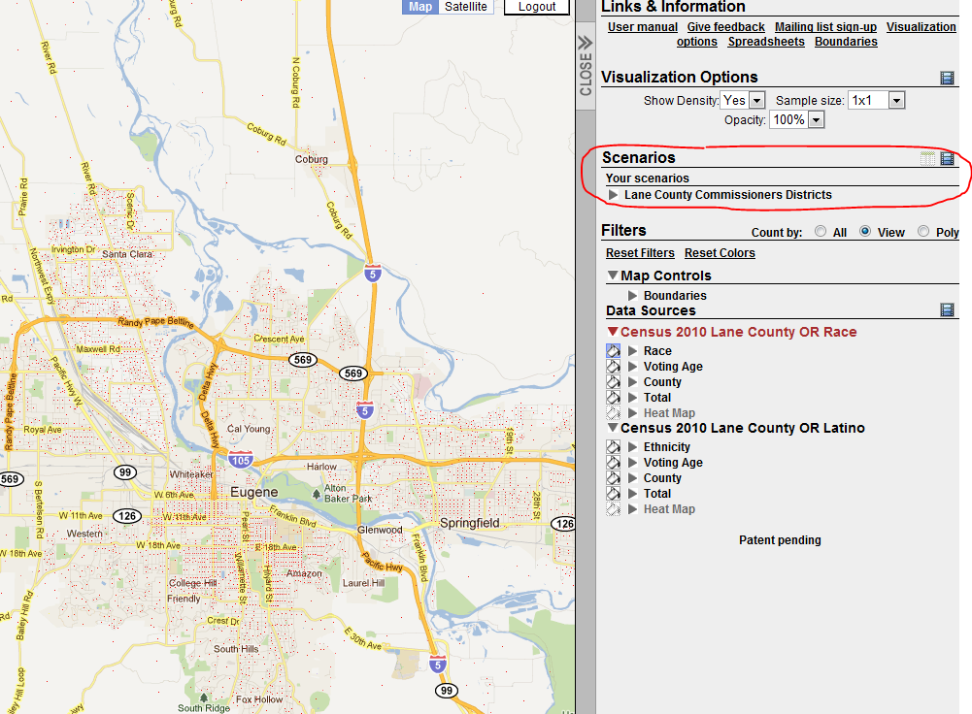

- Under “Scenarios” click on the link that says “Lane County Commissioner Districts” to see a drop down list of the Scenario Options.

- In order to view a Scenario, you need to click on the Box in front of the Scenario to activate it. 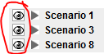 Once you’ve clicked the box in front of the Scenario, click on the corresponding title; “Scenario 1”, “Scenario 3”, or “Scenario 8”. You will see population numbers to the right that show the population breakdown by District for that particular scenario.

- The view of the map is now displayed. You can zoom in and out on the map itself very similar to Google maps.

- View optional boundaries, such as the Current District Boundaries, Legislative Boundaries, School districts, etc. In order to do this:

  - Activate a Scenario (click on the box beside it, then the title).
  - Click on “Boundaries” under Map Controls (see picture)

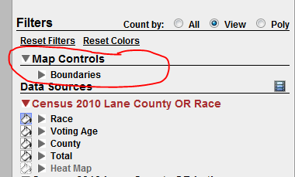

  - Select one or many boundaries to display by checking the box in front of the boundary.

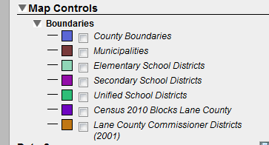

For example: To display the Existing County Commissioner Boundaries click on the last option, “Lane County Commissioner Districts”. To display the boundary line more prominently, click on the line in front of the colored box to make that line thicker.

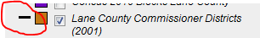

Zooming: In order to move around in the map, just move your mouse over an area. Click your mouse and drag the Hand around to pan. To zoom, either double click, use the scroll option in the far left corner of your screen (picture below) or use the scroll tool on your mouse. 