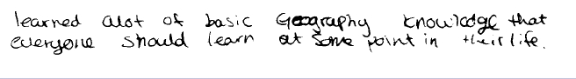
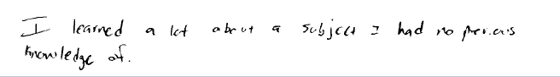
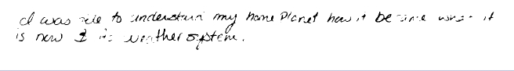
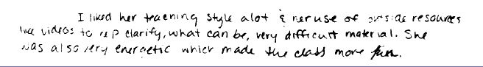
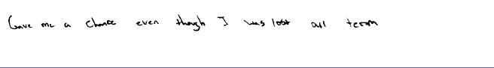
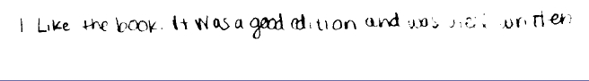
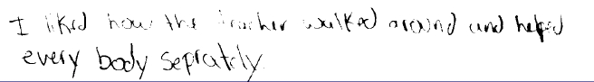
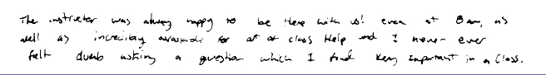
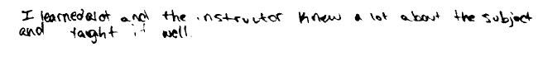
Course Evaluations - Fall 2013
Social Science
Jane Benjamin

A

A

A

A

A

A

A

A

A
A. What did you like about this class?
B. How could this class be improved?

GEOG141 Natural Environment
Confidentiality not marked.

CRN: 21078

Tuesday, February 18, 2014 Page 9 of 154

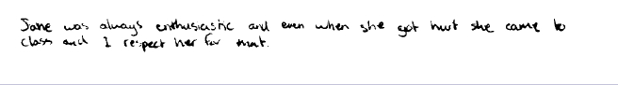
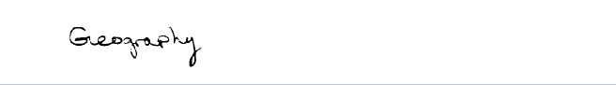
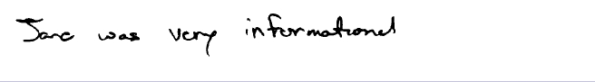
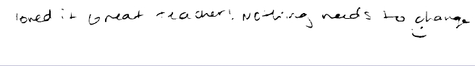
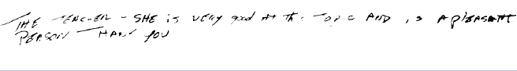
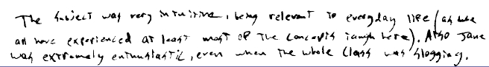

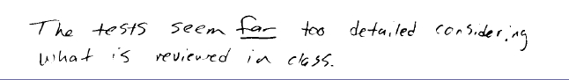
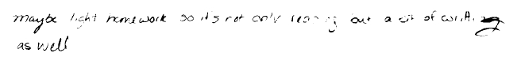
Course Evaluations - Fall 2013
Social Science

A

A

A

A

A

A

A

B

B
A. What did you like about this class?
B. How could this class be improved?
Confidentiality not marked.

Tuesday, February 18, 2014 Page 10 of 154

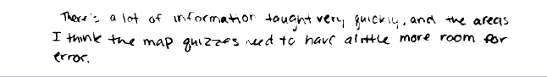
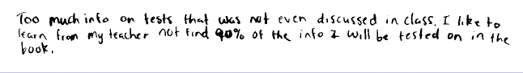
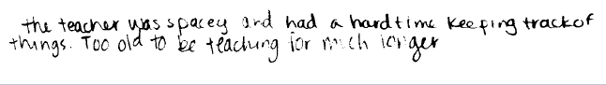
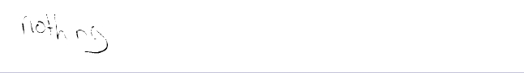
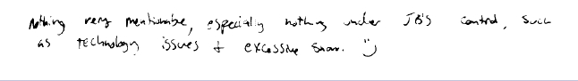
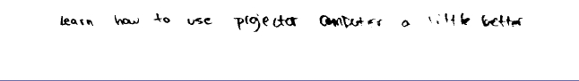
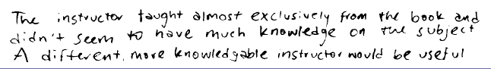
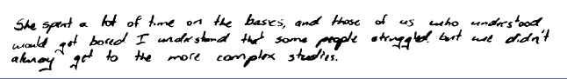
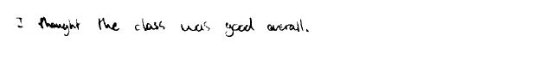
Course Evaluations - Fall 2013
Social Science

B

B

B

B

B

B

B

B

B
A. What did you like about this class?
B. How could this class be improved?
Confidentiality not marked.

Tuesday, February 18, 2014 Page 11 of 154

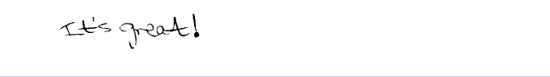
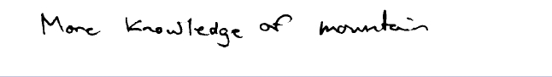
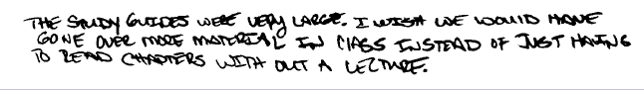
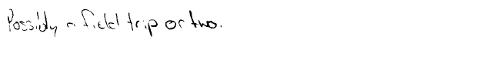
Course Evaluations - Fall 2013
Social Science

B

B

B

B
A. What did you like about this class?
B. How could this class be improved?
Confidentiality not marked.

