This is the text we will be using for the summer Human Geography course.
Titan bookstore will have copies available new @ $104 and possibly some used.
You may rent or (purchase) it used through chegg.com for $23.95 or ($81.00); or other online book vendors. If purchasing on line please order at least one week in advance of class.
home / textbooks / nature / ecology / fundamentals of the human mosaic

Fundamentals of the Human Mosaic

A Thematic Introduction to Cultural Geography
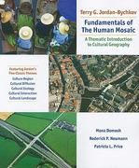

Note: Chegg does not guarantee supplemental material with textbooks(e.g. CDs, DVDs, access codes, or lab manuals).
ISBN:

1429272007

ISBN-13:

9781429272001

AUTHORS:
Terry G Jordan-Bychkov, Jordan-Bychkov ... Show more »

